CSC 541/741

**Software Testing**

# Spring 2023

**Assignment 7**

**Decision Table and Boundary Value Analysis/Testing**

04/06/2023

The purpose of this assignment is to practice the Boundary Value Analysis/Testing method.

NSB offers a travel package for their customers. The package costs $120 dollars for each person. However, the company provides attractive prices for group travel: 2-9 people traveling together will receive 10% discount; 10 people or more will receive a 15% discount. It also takes into account students and military service. Students are eligible for 15% discount and military service-personal to pay only 50% of the standard rate. A person cannot receive both student discount and military discount at the same time. The discounts can be accumulated, and should be maximized.

To complete this assignment, you will need to:

Test-driven

1. Analyze the above problem, and draw an original decision table before merging any rules in the table.

|  |  |  |  |  |  |  |  |  |  |  |  |  |
| --- | --- | --- | --- | --- | --- | --- | --- | --- | --- | --- | --- | --- |
|  | 1 | 2 | 3 | 4 | 5 | 6 | 7 | 8 | 9 | 10 | 11 | 12 |
| 1 person  (0%) | X | x | X | X |  |  |  |  |  |  |  |  |
| 2-9 people  (10%) |  |  |  |  | x | x | x | x |  |  |  |  |
| 10+ people  (15%) |  |  |  |  |  |  |  |  | x | x | x | X |
| Student  (15%) | x |  | X |  | X |  | X |  | X |  | X |  |
| Military  (50%) |  | x | X |  |  | x | x |  |  | x | x |  |
| Total Cost | 102 | 60 | 60 | 120 | 90 | 48 | 48 | 108 | 84 | 42 | 42 | 102 |

1. Draw a final decision table after merging the rules in (1) if possible.

|  |  |  |  |  |  |  |  |  |  |
| --- | --- | --- | --- | --- | --- | --- | --- | --- | --- |
|  | 1 | 2 | 3 | 4 | 5 | 6 | 7 | 8 | 9 |
| 1 person  (0%) | X | x | X |  |  |  |  |  |  |
| 2-9 people  (10%) |  |  |  | x | x | x |  |  |  |
| 10+ people  (15%) |  |  |  |  |  |  | x | x | X |
| Student  (15%) | x | - |  | X | - |  | X | - |  |
| Military  (50%) |  | x |  |  | x |  |  | x |  |
| Total Cost | 102 | 60 | 120 | 90 | 48 | 108 | 84 | 42 | 102 |

1. Based on your table in (2), write a Java code to determine the total amount for a group of 1 or many people.

public class Assignment7 {

public static int calc_cost(int groupSize, boolean military, boolean student){

if (groupSize==1){

if (military){

return 60;

}

else if (student){

return 102;

}

return 120;

}

else if (groupSize>=2 && groupSize <=9){

if (military){

return 48;

}

else if (student){

return 90;

}

return 108;

}

else if (groupSize>9){

if (military){

return 42;

}

else if (student){

return 84;

}

return 102;

}

else {

return 0;

}

}

}

1. Design a set of test cases based on the Boundary Value Analysis method.

Test case 1: 0 people. Expected output: 0.

Test case 2: 1 person, not military or student. Expected output: 120.

Test case 3: 1 person, military and student. Expected output: 60.

Test case 4: 1 person, student and not military. Expected output: 102.

Test case 5: 2 people, not military or student. Expected output: 108.

Test case 6: 2 people, military and student. Expected output: 48.

Test case 7: 9 people, student and not military. Expected output: 90.

Test case 8: 10 people, not military or student. Expected output: 102.

Test case 9: 10 people, military and student. Expected output: 42.

Test case 10: 10 people, student and not military. Expected output: 84.

1. Write a JUnit file to test your code in (3) with the Boundary Value Analysis, and take a snapshot of the testing results.

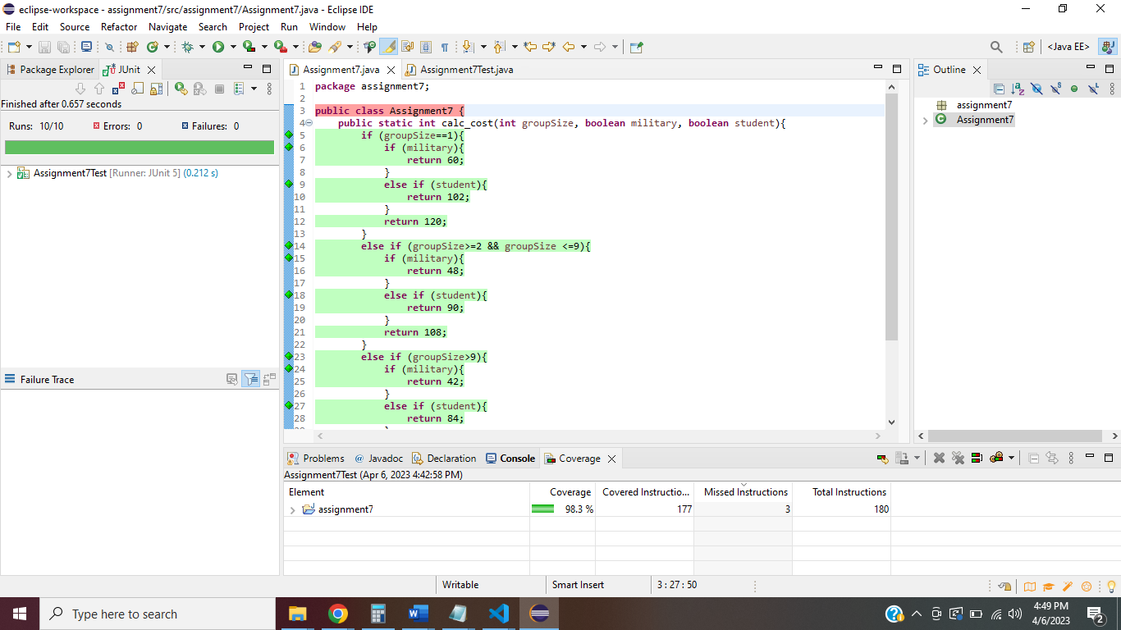

1. Put your answers of (1) to (5) in a Word document.
2. Compress your Word document and your Java code into a zipped file, and submit the zipped file to EKU Blackboard.

Due date: 04/13/2023